Business Process: Inactive Usage Disconnections

Contact
Business Process Owner | Billing Operations - Billing Exception Management (BEM)  Revenue Assurance – Credit
Subject Matter Expert(s) | Armando Barron, Joshua Dunn
Key Contact(s) | Carol Cerqueda (BEM)  Erin Mckinney (Credit)
Key Role | Customer Services Representative II (BEM)
Date Created | 3/5/2026

Business Process Overview
Inactive (INA) Usage Disconnection Process Overview:
- The Inactive Usage Report identifies Installations with INA
- The INA Disconnections Report schedules disconnections and flags exceptions
  - Switch-enabled meter disconnections are processed remotely
  - Non-switch-enabled meters disconnections are managed by Field Metering
- The INA Disconnection Letter Report generates an SAP spool of INA letters, which Credit delivers to Image Production and Postal Services (IPPS) for mailing
Business Unit Responsibilities:
- Billing Exception Management (BEM): Manage INA disconnection process and communicate target INA disconnection count to Credit
- Credit: Cancel INA disconnections, deliver INA letters to IPPS, and report the daily INA disconnections through DL2 and DL3 Selections email to stakeholders
- Field Metering: Manage INA disconnections for non-switch-enabled meters and execute the Master-Metered Multifamily Accommodation and Mobile Home Park Billing (RSMM) disconnect process ensuring compliance with the MUD Act
- Image Production and Postal Services (IPPS): Manage mailing INA letters

Business Process Assumptions
(Assumptions pertaining to the business process)
People | - Assumptions:  - Understand Contract Management  - Complete Commercial Training  - Prerequisites:  - Billing Foundations Training  - Billing and Invoicing  - Understand Meter to Cash process and systems  - Provisioned:  - Access INA reports network directory file (\\sapifs\prd\sap_ccs\reports\inactive_usage)  - Access INA Database network directory file (K:\Billing\NotSafeForMigration\InactiveUsageDatabase)  - Itron Enterprise Edition (IEE) application  - SAP Schedule INA Disconnections  - Utility IQ (UIQ) application  - Dependencies:  - Branding approved INA letter template  - Contact Center supports INA disconnection call volume  - Credit delivers INA letters to IPPS  - IPPS ensures INA letters sent to our customers  - Field Metering  - manage non-switch-enabled meter disconnections  - post door flyers for Master-Metered Multifamily Accommodation and Mobile Home Park Billing (RSMM) MUD Act Compliance
Process | - Assumptions:  - Inactive Usage Report populates Installation records for Inactive Usage Disconnections Report  - Inactive Usage Disconnections Report populates Installations for Inactive Usage Disconnection Letter Report  - Inactive Usage Disconnections Letter Report generates spool for INA letters  - Prerequisites:  - Meter Data Collection (UIQ) and Validation (IEE)  - Scheduled Meter Reads (Bill Orders) Creation  - Dependencies:  - Meter Data Collection Utility IQ (UIQ)  - Meter Data Validation (IEE)  - SAP obtains Register Reads from IEE  - Scheduled Meter Reads (Bill Orders) Creation
Technology | - Assumptions:  - Inactive Usage Report  - Identify Installations without Contracts for the previous five Bill Cycles using their Scheduled Meter Read Dates  - Retrieve Register Reads from IEE  - Calculate INA usage by subtracting Scheduled Meter Read from Move Out Read and applying meter multiplier  - Filter Installations where the total INA usage exceeds 100 kWh  - Filter Installations where Move Out Date is more than 1 day in the past  - Output Inactive Usage Report results to a network directory  - Inactive Usage Disconnections Report:  - Evaluate Installations for exceptions prior to scheduling disconnections  - Does not schedule more than target disconnections any given day  - Remove Disconnection Lock from Installation where Utility IQ (UIQ) meter Administrative Status = Active  - Create Device Location Notes including amount of INA usage  - Create Disconnect Order  - Create Service Notification for Switch and Non-Switch enabled meters  - Create Contact Log  - Execute Remote Disconnections and close Service Notification (SN) for switch enabled meters  - Create Disconnection Entry  - Output results include successes and exceptions to a network directory  - Inactive Usage Letter Report  - Select INA Disconnections from Disconnection Report results  - Enable user(s) to reprint INA Disconnections Letters as needed  - Spool generated using SMUD Branding approved letters  - Letters reflect Service Address and Target Disconnection Date for each Installation  - Prerequisites:  - SAP populates Schedule Meter Reads (Bill Orders)  - SAP retrieves meter data from IEE  - Dependencies:  - ESB  - Itron Enterprise Edition (Meter Data Management System)

Process Flowchart
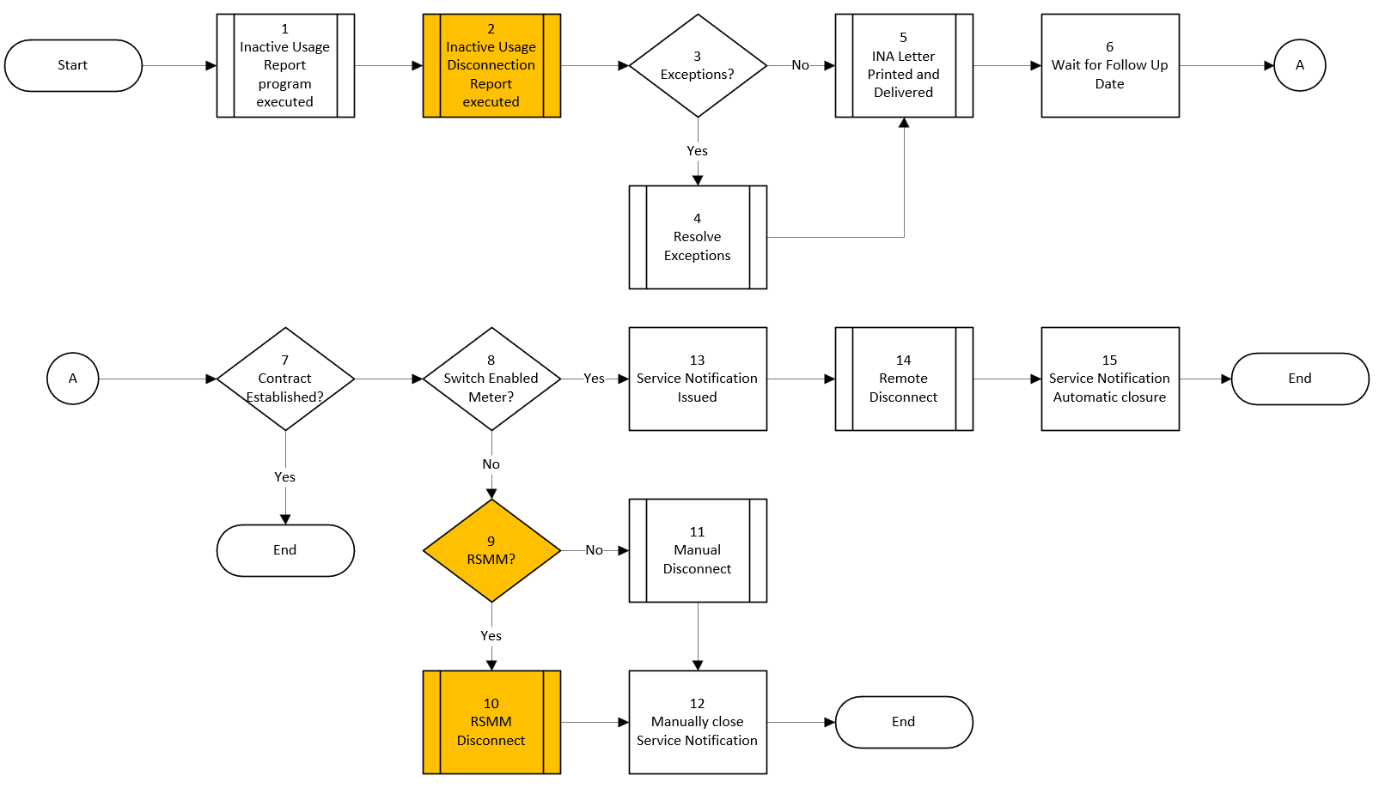

Task Description
Id | Task Description | Procedure
1 | Inactive Usage Report program executed | Generate INA report  Store results in \\sapifs\prd\sap_ccs\reports\inactive_usage
2 | Inactive Usage Disconnection Report executed | Generate Inactive Usage Disconnection Report  Store results in \\sapifs\prd\sap_ccs\reports\inactive_usage
3 | Exceptions | Identify exceptions preventing INA Disconnection Report from scheduling INA disconnects from step 2
4 | Resolve Exceptions | BEM reviews and resolves exceptions
5 | INA Letter Printed and Delivered | Create SAP spool, output INA letters for Credit  Credit delivers letters to IPPS  IPPS mails letters to our customers
6 | Wait for Follow Up Date | Wait number of business days specified from step 2
7 | Contract Established? | Check for active Contract at Installation
8 | Switch Enabled Meter? | Determine type of meter associated with the INA workflow (switch or non-switch)
9 | RSMM? | Determine if Installation is Master-Metered Multifamily Accommodation and Mobile Home Park Billing (RSMM) Rate
10 | RSMM Disconnect | Execute steps required by MUD act to ensure Master-Metered Multifamily Accommodation and Mobile Home Park Billing (RSMM) disconnect process compliance, Field Metering must deliver a door flyer and follow up after a prescribed number of business days for disconnect activities
11 | Manual Disconnect | Field Metering executes manual disconnections
12 | Manually Close Service Notification | Field Metering closes Service Notifications (SN) after manual disconnects completed
13 | Service Notification Issued | Inactive Usage Disconnection SN are created
14 | Remote Disconnect | Remote disconnects processed and Field Services are not required
15 | Service Notification Automatic closure | SN is automatically closed following confirmation of automated disconnection from step 14

Business Rules
Id | Event Name | Business Rules
1 | Inactive Usage Report program executed | - Report and output results must be completed prior to step 2
2 | Inactive Usage Disconnection Report executed | - Does not schedule more than 100 disconnections any given day  - Does not schedule INA disconnections on Non-Business Days or Legal Holiday pursuant to MUD Act
4 | Resolve Exceptions | - Do not schedule INA disconnection on Friday using 6 business days  - Do not use CICO INA Workflow for non-residential Installations  - BEM notifies Billing Solutions for Interim Service Agreements, Streetlights, or Traffic Signals with INA  - BEM notifies Accounting for SMUD Accounts with INA  - BEM notifies Strategic Account Advisors (SAA) for Cell Sites with INA  - BEM contacts Field Metering to follow up on outstanding INA SN
5 | INA Letter Printed and Delivered | - SMUD Branding approved letters printed and delivered to IPPS by Credit
10 | RSMM Disconnect | - Customize Service Notification (SN) to include RSMM elements to notify Field Metering to post the door flyers pursuant to MUD Act
12 | Manually Close Service Notification | - Field Metering close SN upon completion to prevent future exceptions
13 | Service Notification Issued | - SN creation starts at 0:00 on the target business day
15 | Service Notification Automatic Closure | - Automated SN closure necessary to prevent future exceptions

Event | Legal Requirements (Optional)  Legal documents/ procedures/ requirements to be fulfilled before/at the specified event.
Id | Event | Legal Requirements
2 | Inactive Usage Disconnection Report executed | - Disconnections are prohibited by MUD Act Compliance (Chapter 6 Article 5 Section: 12824) for Saturday, Sunday and Legal Holidays as well as any time when business offices are not open to public.
10 | RSMM Disconnect | - MUD Act Compliance with disconnection activities (Chapter 6 Article 5 Section: 12822.1. a) which specifies disconnection requirements for RSMM, the district shall place a written notice on the door of each residential unit at least 15 days prior to termination.

Pain Points and Improvement Opportunities
- Inactive Usage Report
  - Unable to identify INA where Move-In reversed
- Inactive Usage Disconnection Report
  - Unable to schedule INA for Installations not identified via Inactive Usage Report, which causes reliance on CIC0 workflow
  - Does not check total number of disconnections scheduled, therefore, can exceed daily target
- CIC0 INA Workflow
  - Cannot be used for Non-residential Installations creates manual work to replicate steps automated by Inactive Usage Disconnection Report and INA Disconnection Letter Report
  - Will be deprecated with S/4HANA
- Embedded Analytics
  - Unable to determine amount of revenue billed for INA disconnects, custom queries created but require manual work and intervention.

Departments impacted by process change (Required)

Department | Type of Change(s) | Action Required
Billing Exception Management | - Inactive Usage Report  - Inactive Usage Disconnections Report  - Inactive Usage Letter Print Report | - Documentation updates  - Training
Branding | - Inactive Usage Disconnections Report | - TBD
Contact Center | - Inactive Usage Disconnections Report  - Inactive Usage Letter Print Report | - Documentation updates  - Training
Credit | - Inactive Usage Disconnections Report  - Inactive Usage Letter Print Report | - Communication
Field Metering | - Inactive Usage Disconnections Report | - Communication  - Training
Field Services | - Inactive Usage Disconnections Report | - Communication  - Documentation updates  - Training
Image Production and Postal Services | - Inactive Usage Letter Print Report | - Communication

Supporting Documentation
(Any subsequent documentation in support of this business process (i.e. business requirements, technical specs, etc.) shall be summarized in the following table.)
Document Type | Link
As-Is Process Map | Inactive Usage Disconnections Process Mapping As Is.vsdx
Business Job-aid | ZCS_INA_DISCO - INA Disconnections Report Job Aid.pdf
Business Job-aid | ZCS_INA_PRINT- INA Disconnections Letter Report Job Aid.pdf
Business Procedures | Inactive Usage Disconnect Process.pdf
Technical Specification | \\server01\dept-btcm\CCS\Specification_Documents\RTR-Reports\RTR-CS343 Inactive Usage Report.docx
Technical Specification | \\server01\dept-btcm\CCS\Specification_Documents\WTR-Workflow\WTR-CS100 Inactive Usage Disconnect Subworkflow.doc
Technical Specification | \\server01\dept-btcm\CCS\Specification_Documents\WTR-Workflow\WTR-CS099 Automated INA Disconnect .doc
Technical Specification | \\server01\dept-btcm\CCS\Specification_Documents\RTR-Reports\RTR-CS405 INA Disconnect via workflow.docx
Technical Specification | \\server01\dept-btcm\CCS\Specification_Documents\FTR-Forms\FTR-CS092_INA_Disco_Letter.docx

Business Blueprint Amendments

Any subsequent changes to this business process blueprint after the official document approval shall be summarized in the following table. This document must be reprinted and signed by the authorized representatives.
Version | Author | Description of Change | Approval (Name/Sign) | Date
1.0 | Joshua Dunn | Initial Draft | Carol Cerqeuda

